Optimizing Neural Nets

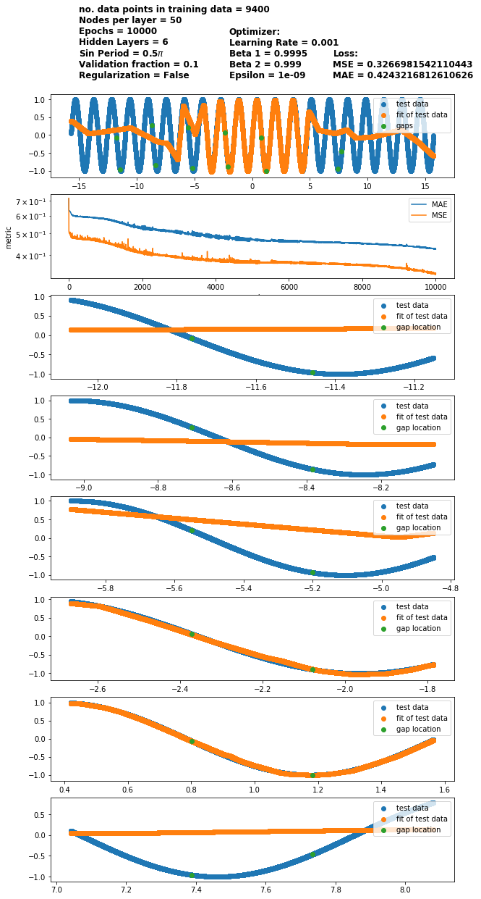

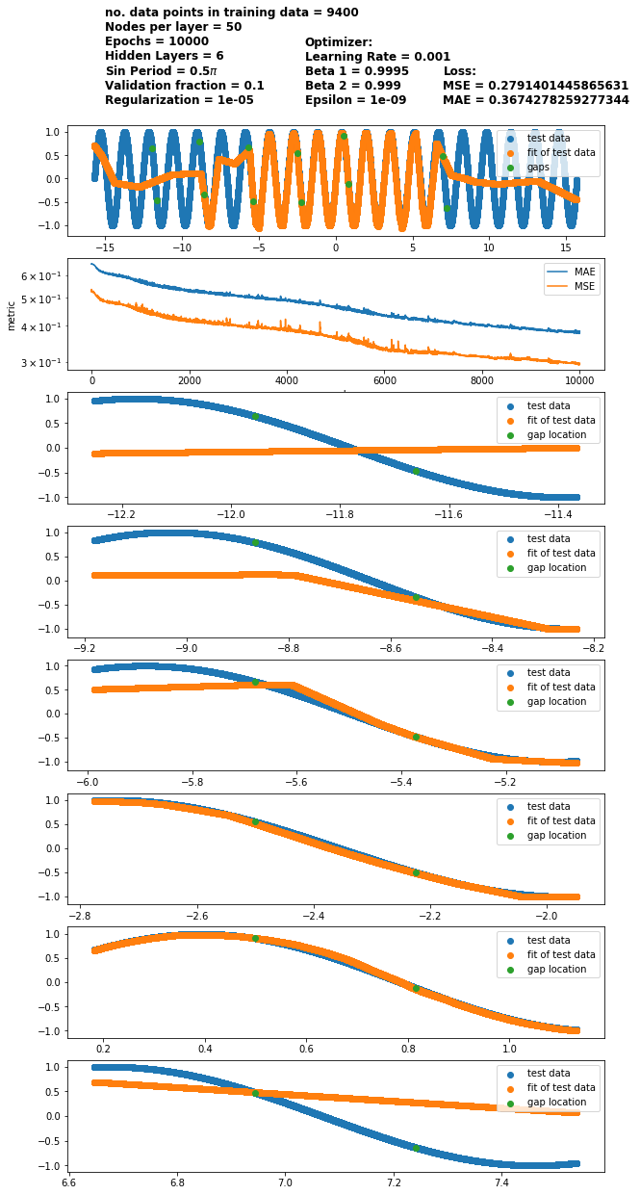

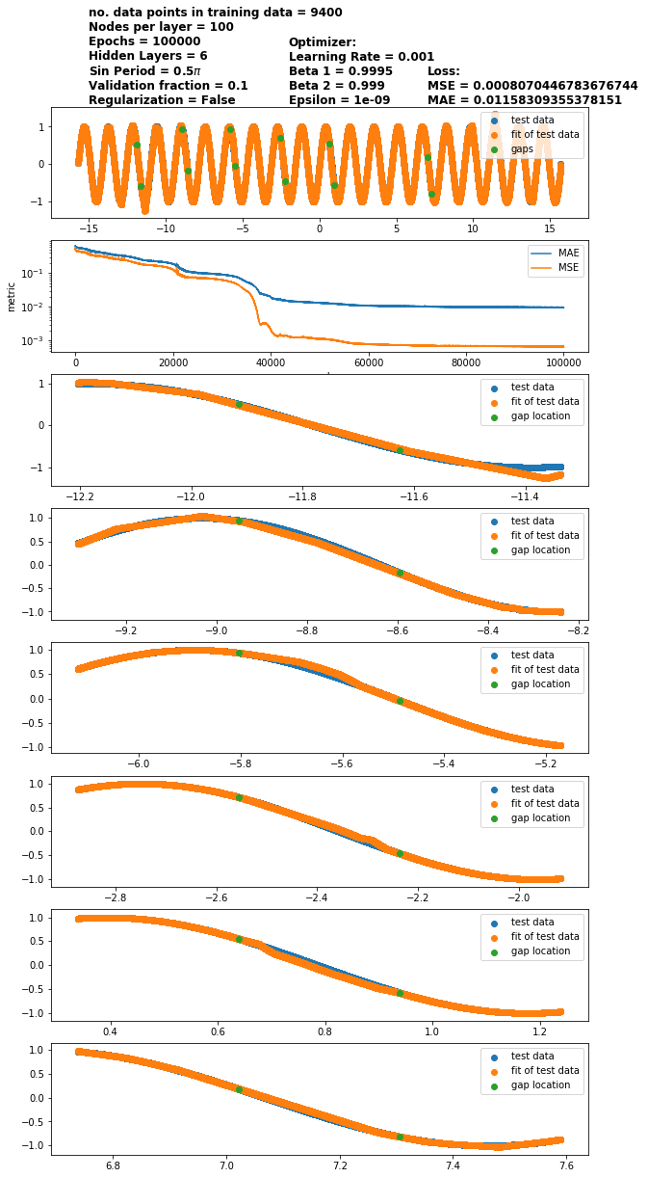

|  |
| --- |
| **Varying Learning Rate** |
| **Varying Beta_1** |
| **Varying Regularization** |
| **Varying Epsilon** |
| **Varying Beta_2** |
| **Varying Epochs** |
| **Varying Nodes** |
| **Varying data points** |